Spark SQL Advanced

1. Dataset vs dataframe
2. Kyro serializer
3. ORC optimizer
4. Spark CONF
5. Spark jobs
6. Spark Catalog
7. Spark Explain plan
8. toPandas

# . <https://docs.databricks.com/spark/latest/spark-sql/query-watchdog.html>

# Query Watchdog

Spark for python developers

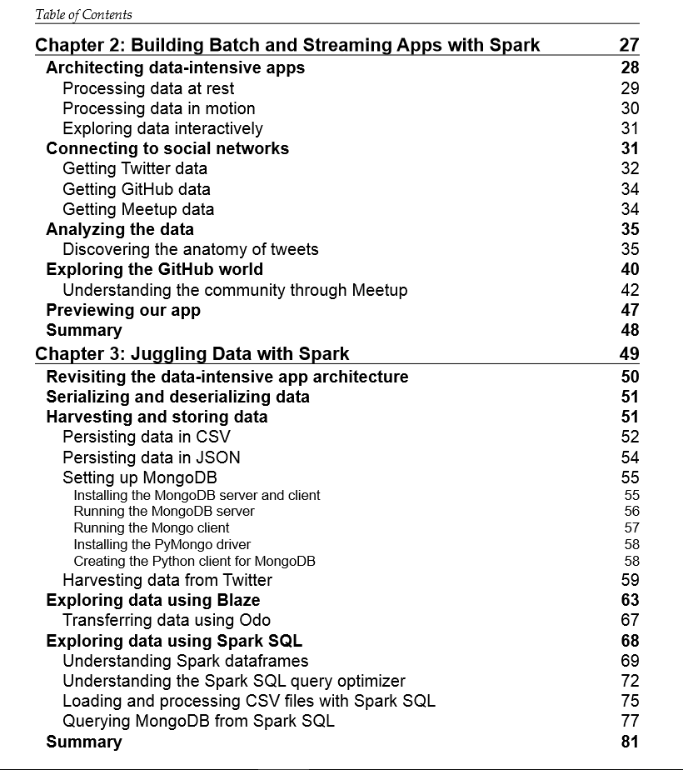

From learning spark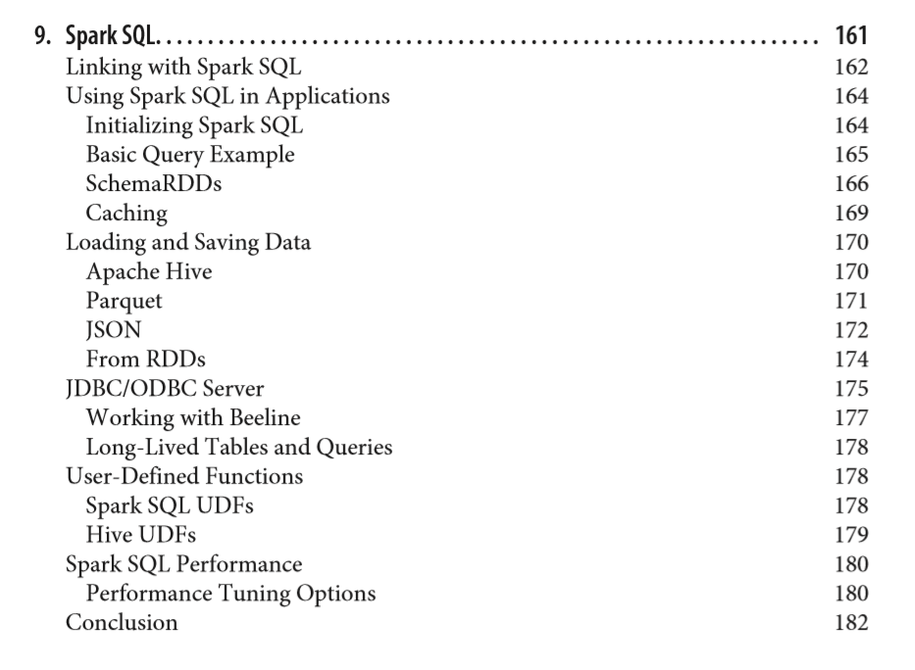

Spark cookbook

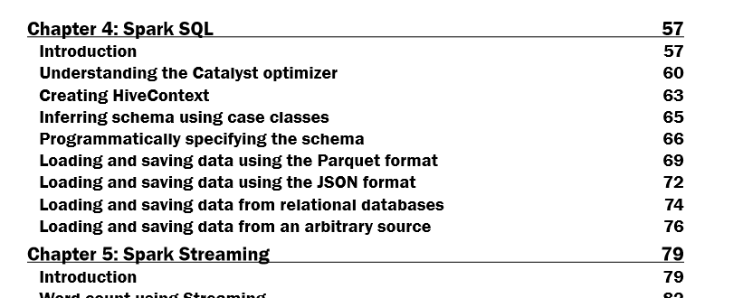

Spark 2, for beginners

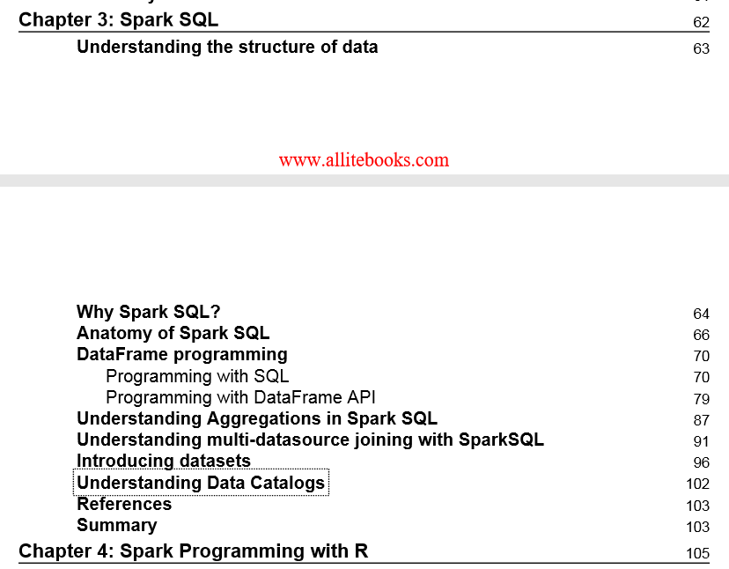

Fast data processing eith spark

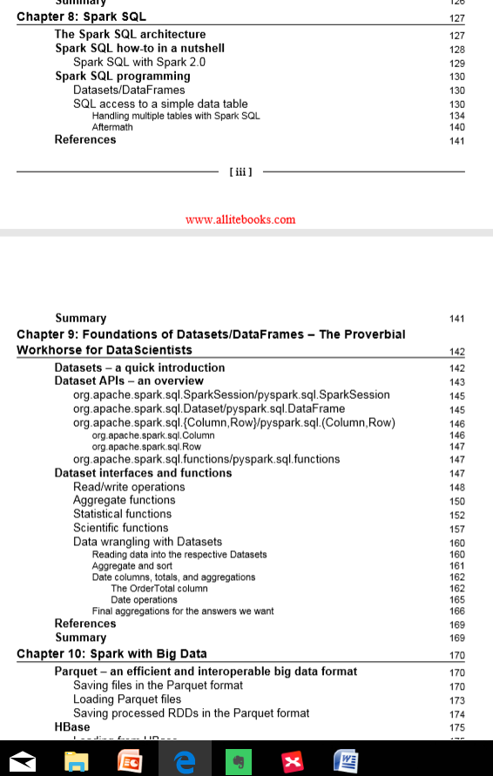

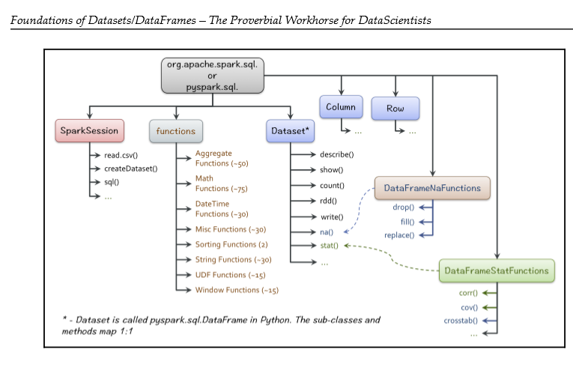

Big data analysis with spark

